**Passenger**

+

name: string

+

address: string

+

gender: character

+

age: int

+

emailid: string

+

mobileno: string

()

+

regester

login

+

()

+

()

viewFlights

()

bookTickets

+

cancelTickets

+

()

()

+

makePayment

logout

+

()

**Reservation System**

flightname: string

+

starting location: string

+

detination: string

+

+

date time: int

+

number of seats : int

+

chooseFlight

()

+

selectTickets

9)

+

makePayment

()

()

+

removeflight

()

modifyseats

+

+

cancel

()

**Payment**

+

customerName: string

customerID: int

+

cardNumber: int

+

cardType: string

+

makePayment

()

+

**Airline Admin**

+

name: string

+

ID: int

+

emailID: string

+

()

updateInfo

()

notifyCustmors

+

updateFlightStatus

+

()

**Flight**

+

FlightName: string

+

FlightNumber: int

FlightStatus: string

+

+

FlightCapacity: int

+

DestinationOfFlight: string

+

FlightPrice: int

+

FlightDuration: string

+

timings

()

+

flightStatus

()

+

notifications

()

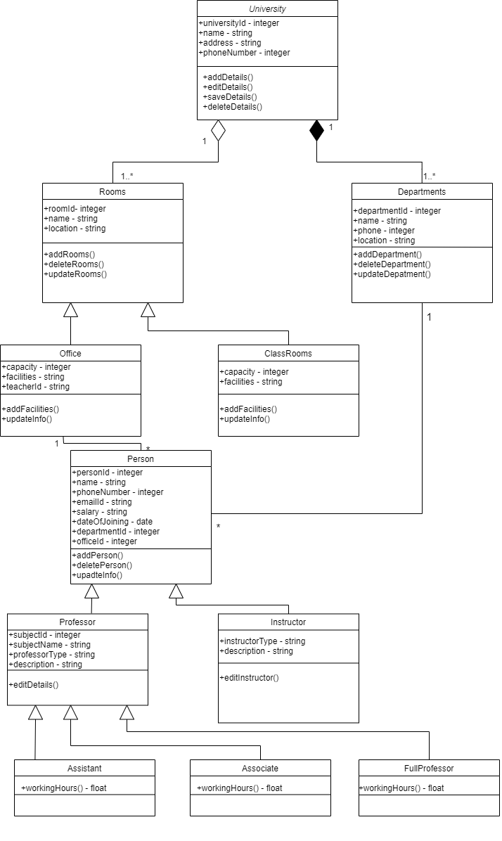

Fill out Enrollment Forms

Enroll in University

Enroll in

seminars

Obtain help to Fill out

Forms

Attend University

Overview Presentation

Make intial tution

Payement

else

incorrect

correct

Help available

trivial problems

|  |  |  |  |  |  |  |
| --- | --- | --- | --- | --- | --- | --- |
| AdminLibrarian |  | LibraryManagementSystem |  | UserCredentialsDB |  | EmailSystem |

